ASSIGNMENT 3
PROGRAM FOR TRAFFIC LIGHT
Python Code:
void setup() {
// put your setup code here, to run once:
Serial1.begin(9600);
pinMode(21, OUTPUT);
pinMode(20, OUTPUT);
pinMode(19, OUTPUT);
}

void loop() {
// put your main code here, to run repeatedly:
digitalWrite(21, HIGH);
delay(3000); // this speeds up the simulation
digitalWrite(21, LOW);
digitalWrite(20, HIGH);
delay(3000);
digitalWrite(20, LOW);
digitalWrite(19, HIGH);
delay(3000);
digitalWrite(19, LOW);
}

OUTPUT:
Traffic Lights For Raspberry Pi
Blinking Red Light:
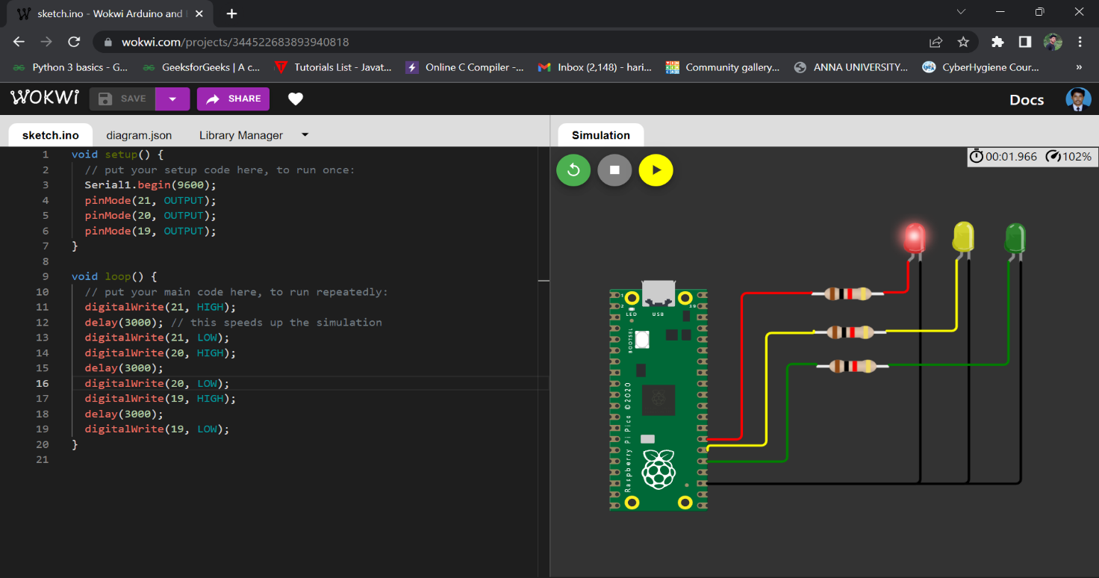
Blinking Yellow Light:
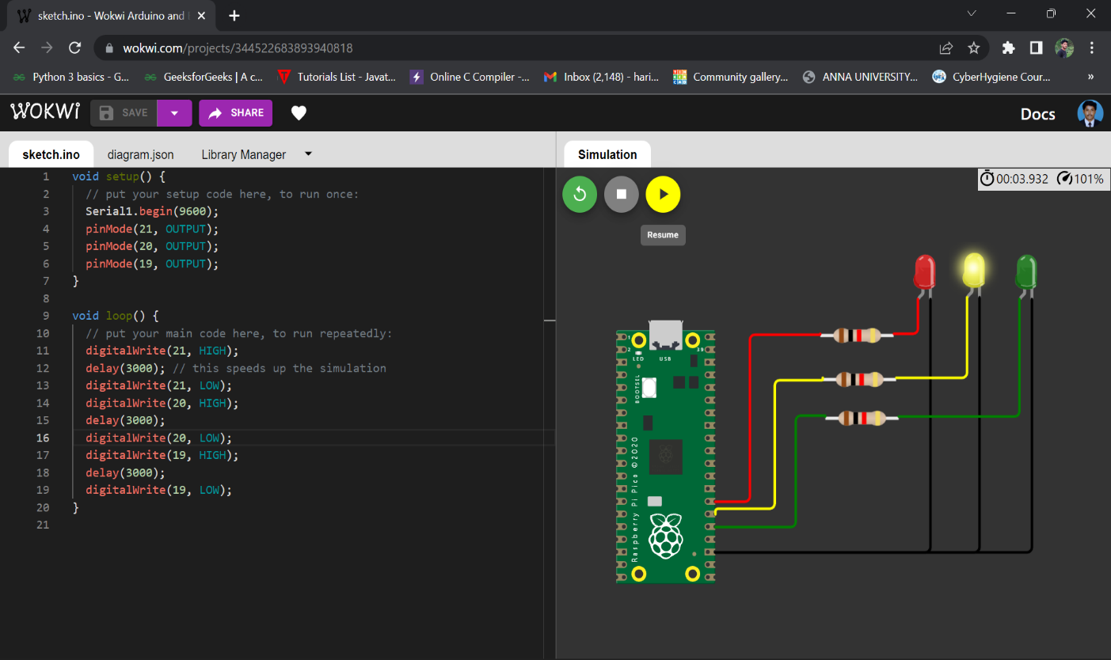

Blinking Green Light:

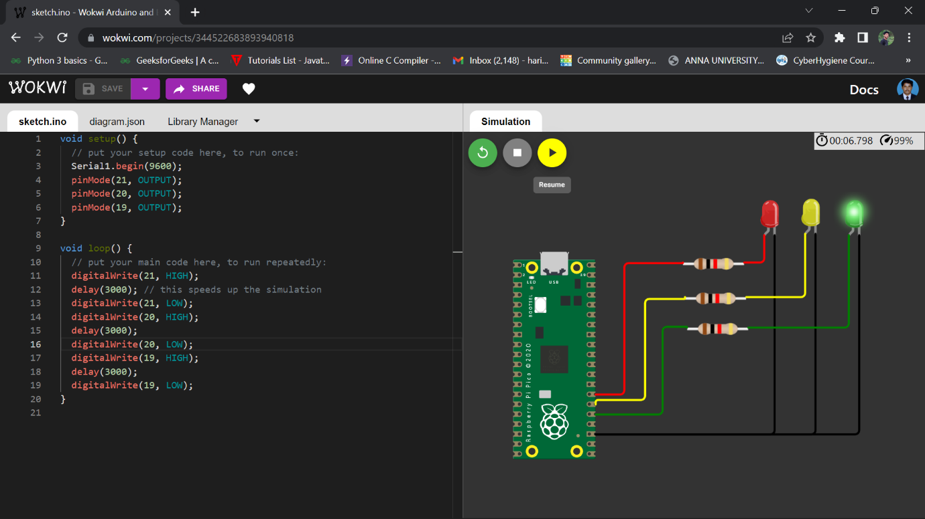
BLINKING LED:
PROGRAM FOR BLINKING LED:
Python code:
void setup() {
// put your setup code here, to run once:
Serial.begin(9600);
pinMode(22, OUTPUT);
}

void loop() {
// put your main code here, to run repeatedly:
digitalWrite(22, HIGH);
Serial.println("LED ON");
delay(2000);
digitalWrite(22, LOW);
Serial.println("LED OFF");
delay(2000);
}

Output:
Blinking LED For Raspberry pi:
